**9.Raspberry Pi platform -------Bluetooth_control**

**1)Introduction of experimental**

In this experiment, we control car by Bluetooth App by Android Mobile phone. The mobile phone sends commands through the serial port to control the advance, backward, turn left, turn right , stop, any angle control of the servo,whistle, speed of car.

At the same time, the status of various sensors on the car and the distance measured by the ultrasonic wave are displayed in real time on the Bluetooth APP interface by the serial port.

**2)Experimental Steps**

**New version APK**

1): Android Please use the browser to scan the QR code to download and install APK; Apple please use camera to scan the QR code to enter the APP Store to download and install or search for "YahboomRobot" in the APP Store. As shown in figure below.

!!Note:Because the software is relatively large, the download takes a certain amount of time, please be patient.



**Note:During installation, If you find any prompts on your phone (for example: location permissions of your phone). You must select "Yes".**

2)::After the APP is installed, open the Bluetooth of the your phone, open the power switch of the Tank, the red indicator of the Bluetooth module keeps flashing.

3)::Then, open the **YahboomRobot** APK. You will see the APK interface and we need to click on the top left corner of the APK to select the device as shown below.

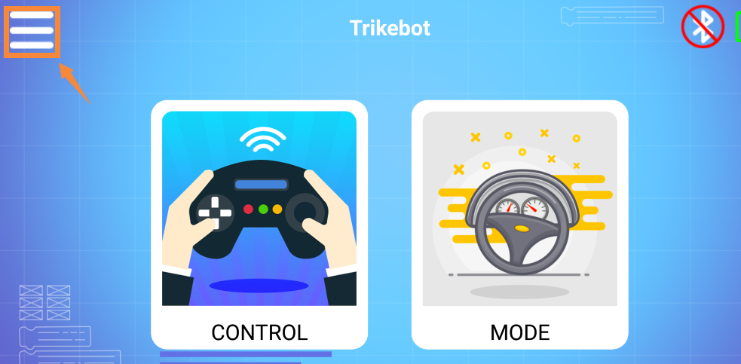

4):: Select 【G1 Tank】to enter the remote control interface, as shown below:

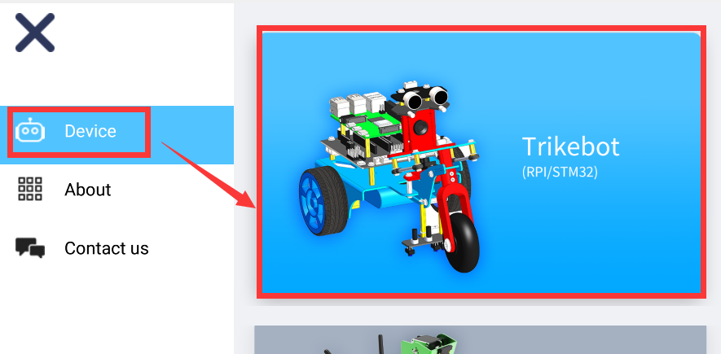

5):: You will this interface as shown below. Click on the top right corner of the APK to connect Bluetooth.

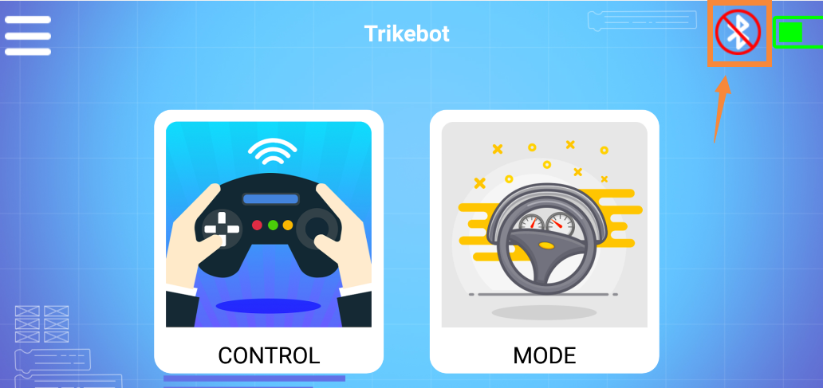

6):You can see bluetooth signal. Wait patiently, the phone will automatically connect to the Bluetooth near the Car.

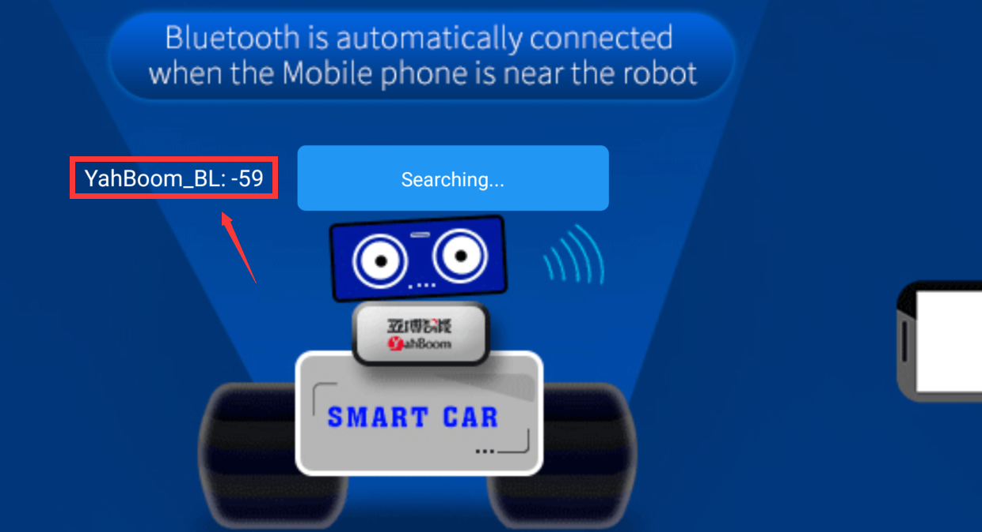

7): Bluetooth can be successfully connected, and the APP will enter the interface as shown below. At the same time, the red indicator of the Bluetooth module will be keep on. You need to click”OK”.

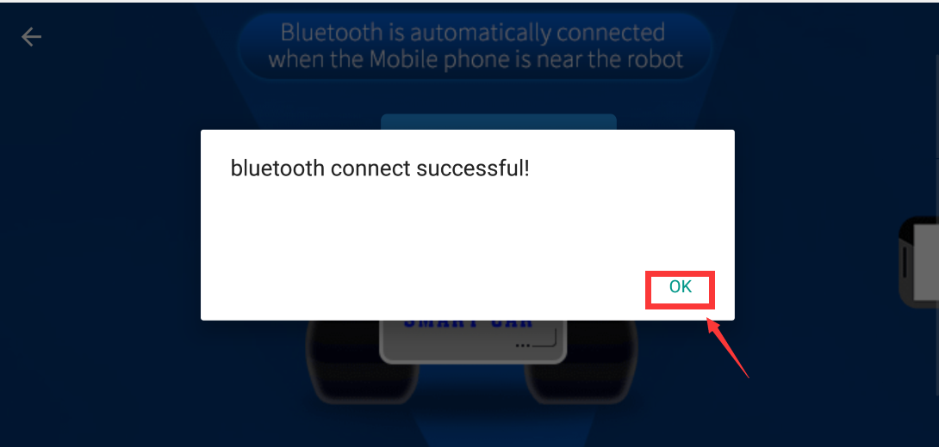

You will enter the interface as shown below.

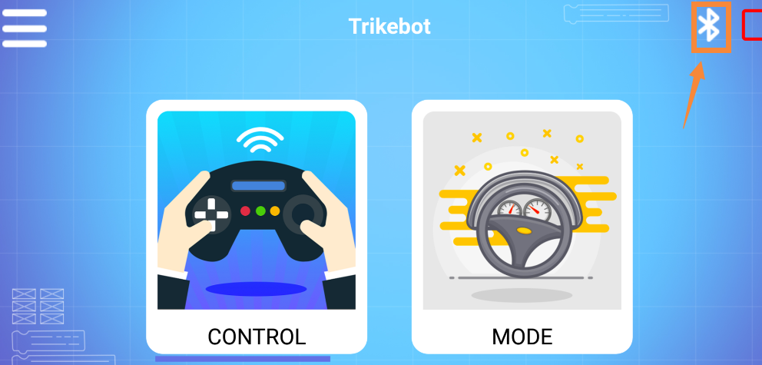

8): Click “CONTROL” to enter interface as shown below. Wait for the ultrasonic data to change, it prove that Bluetooth starts to transmit data normally. You can start to control the car.

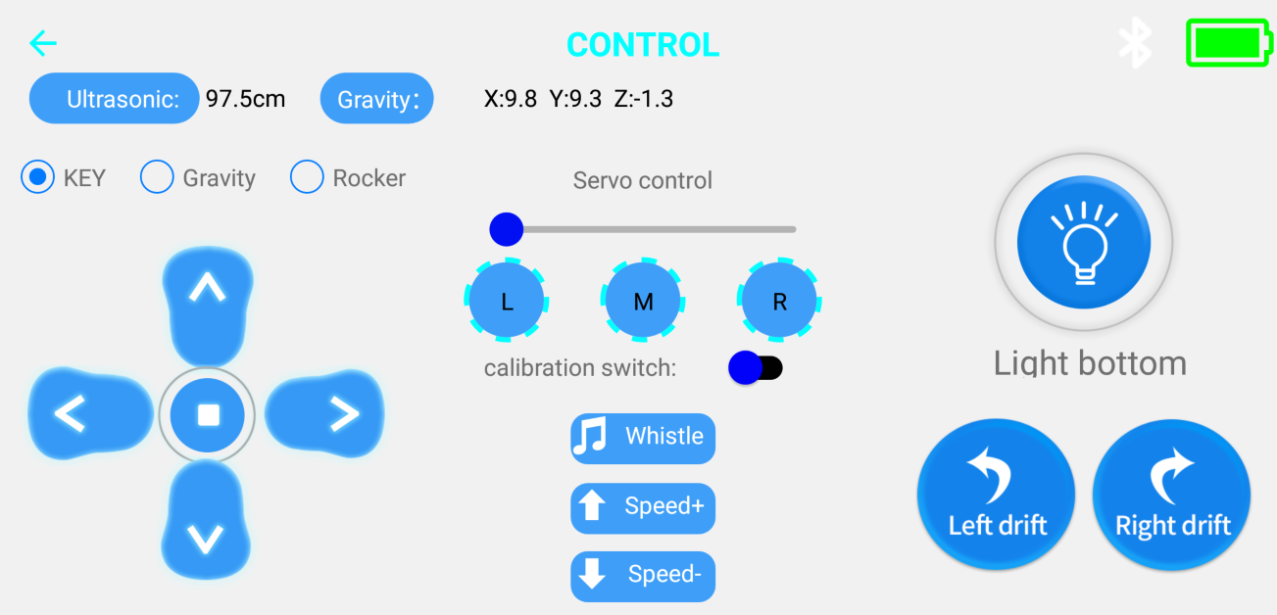

9): Click “ MODE” to enter interface as shown below.

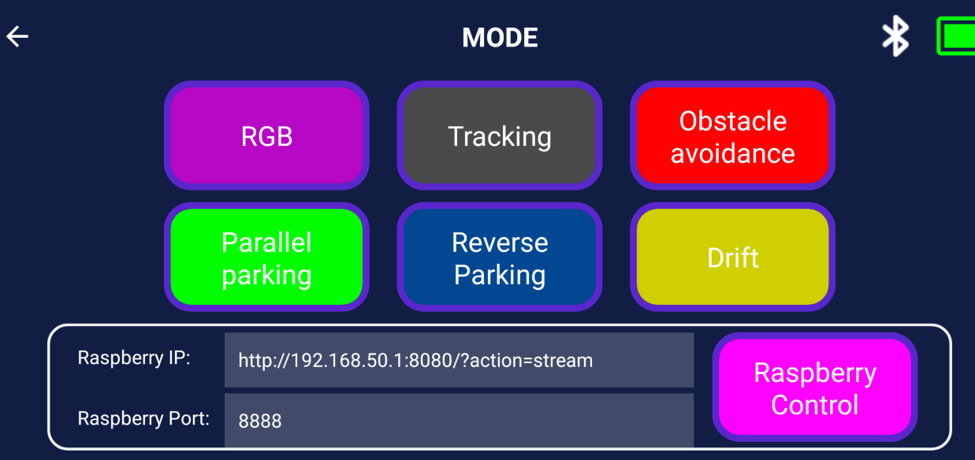

You need to pay attention to the points, otherwise the Bluetooth remote control function will have problems.

****Note:****

****（1）The robot Tank needs to have enough voltage to work properly. Please refer to the following figure for the charging method and battery usage:****

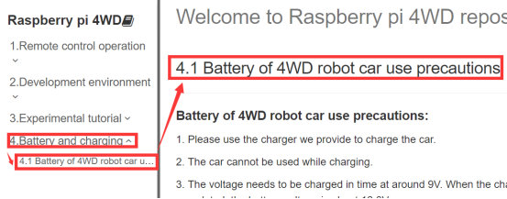

****（2）The Bluetooth module needs to be properly inserted into the expansion board of the Tank. As shown in the figure below.****

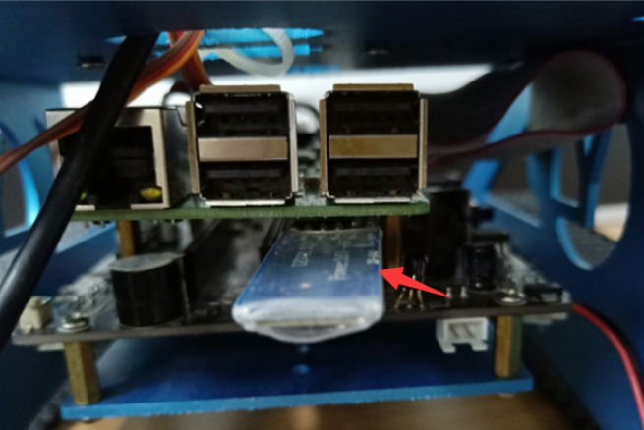

****（3）51/Arduino Download Switch on the expansion board must be set to [OFF]. As shown in the figure below.****

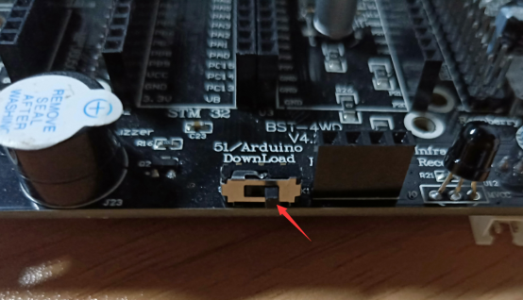

(4) The ultrasonic module must be inserted. As shown in the figure below.

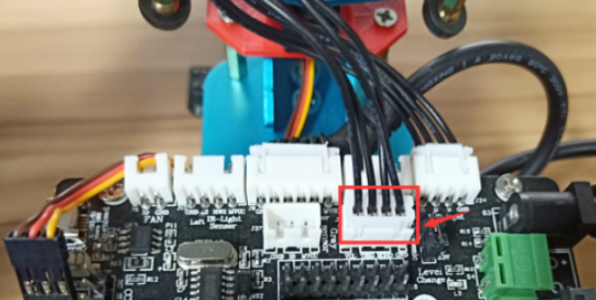

Please read our manual for introductions of Bluetooth remote control interface.

**About camera:**

If you want to use camera, you need to connect the camera and the Raspberry Pi motherboard correctly.

Your phone must connect WiFi of the Tank. Aa shown below.

**Name: Yahboom_TrikeBot**

**Password: 12345678**

This WiFi is only used to transmit video and cannot be accessed online.

When you connect to WiFi, Click “**RaspberryControl**” you can see the picture taken by the camera on your mobile phone.

**IP address for 4B image:**

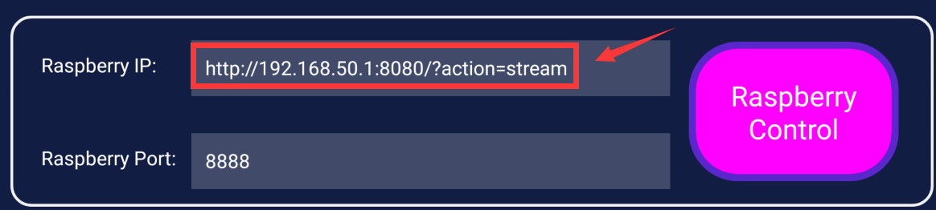

**IP address for 3B+ image:**

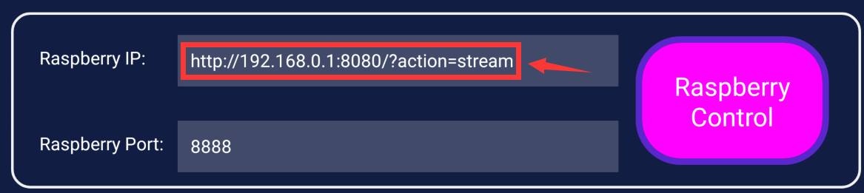

Video as shown below.

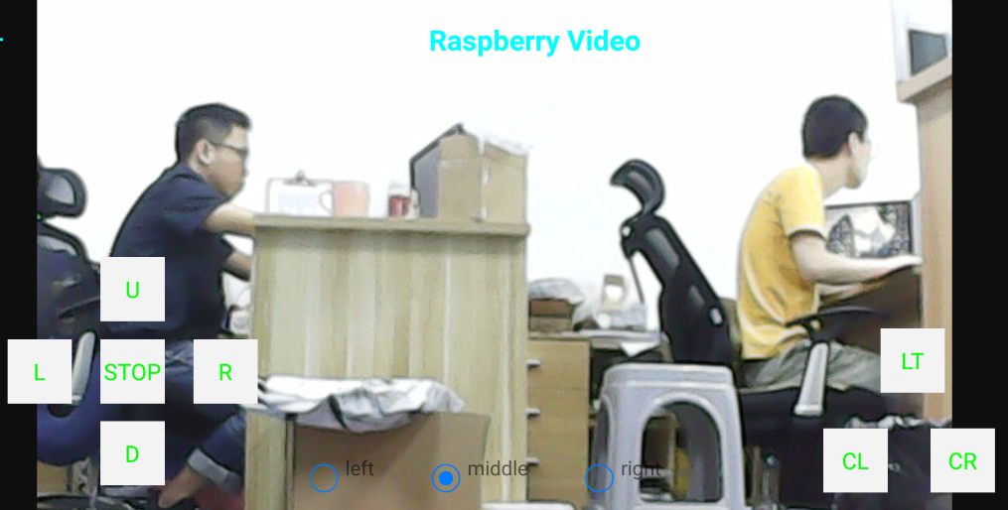

**Old version APK**

(1) You need to install the 【Yahboom TrikeBot Controller】 software on your Android mobile phone, turn on the power switch of the car(the red indicating light of the Bluetooth module is flashing). You should open the Bluetooth on your Android mobile phone and open the 【Yahboom TrikeBot Controller】 software. Bluetooth is automatically connected when the Mobile phone is near the robot.

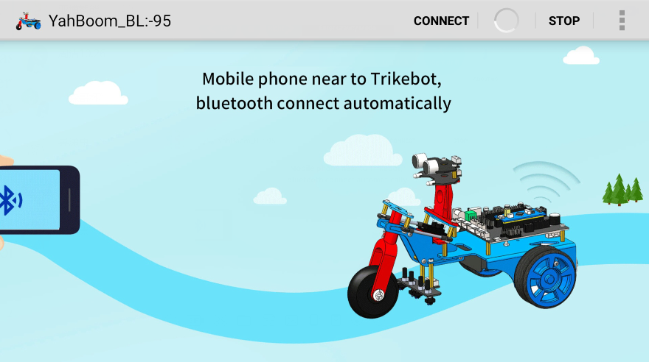

1. After successful connection,enter the main control page.You can choose 3 ways of remote control.

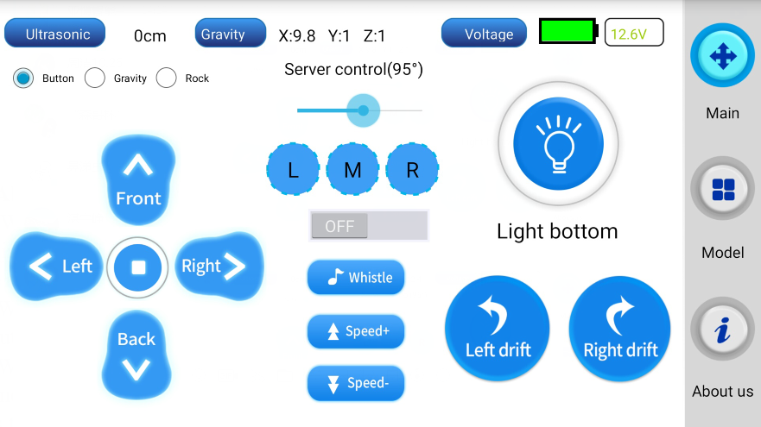

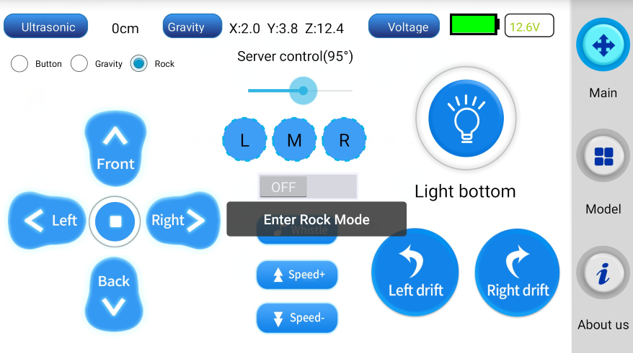

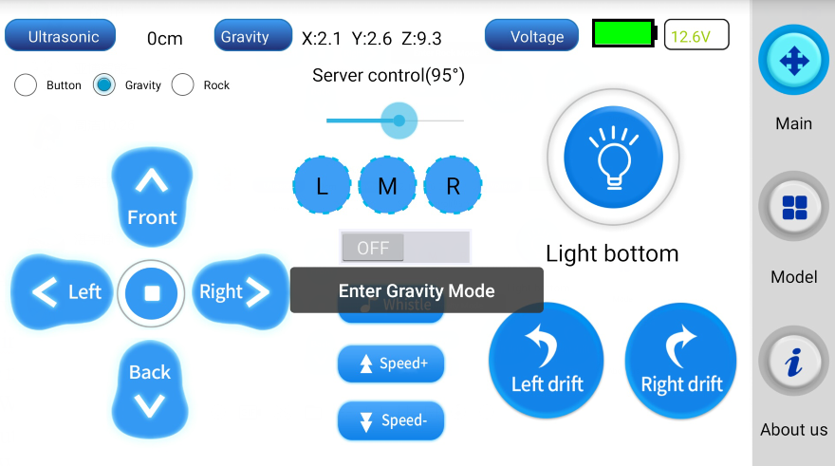

1. You can click Mode button to choose different Mode.

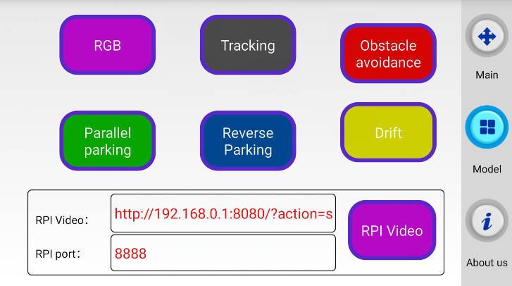

**3) About the code**

1. We need to compile this file in the Raspberry Pi system. (Note: we need to add -lwiringPi and -lpthread to the library file.)

We need to input:gcc bluetooth_control.c -o bluetooth_control -lwiringPi -lpthread

(2)We need to run the compiled executable file in the Raspberry Pi system.We need to input: ./bluetooth_control

(3)We can input: ctrl+c to stop this process, which mean is send a signal to the linux kernel to terminate the current process, but the state of the relevant pin is uncertain at this time, we also need to run a script to initialize all pins.

(Note:The initpin.sh script file is included in the SmartCar directory.)

You need to input:  chmod 777 initpin.sh

./initpin.sh

After completing the above steps, the experiment is over.

**!!!Note:**

**1. The Bluetooth module needs to be properly inserted into the expansion board of the robot car.**

**2. 51/Arduino Download Switch on the expansion board must be set to [OFF].**

**3. The ultrasonic module must be inserted.**